**ADF Company Questions**

### 1) Arrays

**1. Find the missing number in a given array**

**Problem Statement**: Given an array of positive numbers ranging from 1 to n, such that all numbers from 1 to n are present except one number x, find x. Assume the input array is unsorted.

3712845

n = 8; x = 6

**2. Determine if the sum of two integers is equal to a given value**

**Problem Statement**: Given an array of integers and a value, determine if there are any two integers in the array whose sum is equal to the given value. Return true if the sum exists, and false if it does not. Consider the following array and its target sums:

5712843

Target Sum107+3=10, 2+8=10

Target Sum19No two values sum up to 19

**3. Set columns and rows as zeroes**

**Problem Statement**: Given a two-dimensional array, if any element within is zero, make its whole row and column zero. Consider the matrix below.

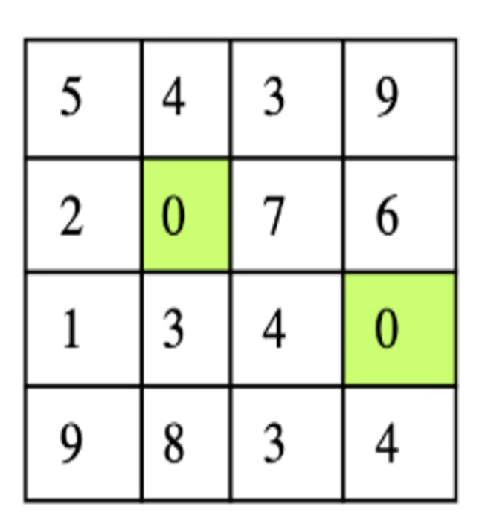

Given matrix

There are two zeros in the input matrix at positions (1,1) and (2,3). The output of this should be a matrix in which the first and second rows become zero and the first and third columns become zero. Below is the expected output matrix.

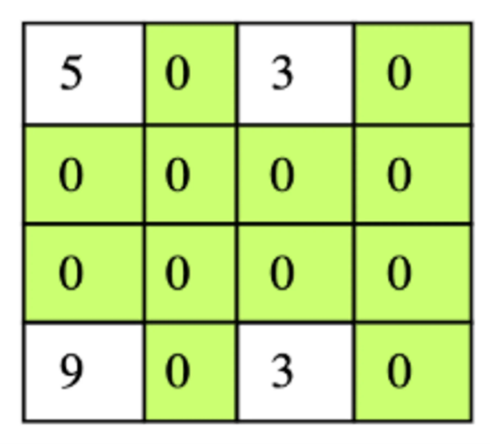

Expected output

**2)Linked List**

**4. Merge two sorted linked lists**

**Problem Statement**: Write a function that takes two sorted linked lists and merges them. The function should return a single, sorted list made from splicing the nodes of the first two lists together.

For example, if the first linked list is 1 -> 2 -> 4 and the second linked list is 3 -> 5 -> 6, then the output would be 1 -> 2 -> 3 -> 4 -> 5 -> 6

**3)Strings**

**5. Reverse words in a sentence**

**Problem Statement**: Reverse the order of words in a given sentence.

**Example**: "sphinx of black quartz judge my vow" should output as "vow my judge quartz black of sphinx"

**6. Find all palindrome substrings**

**Problem Statement:** Given a string, find all non-single letter substrings that are palindromes.

**Example:**

An string input of "poppopo" would return "pop", "opo", "oppo", and "poppop".

.

**7. Find the longest path in a given matrix**

**Problem Statement**: Given an n*n matrix where all numbers are distinct, find the longest path starting from any cell such that all cells along the path increase in order by 1.

**4)Math and Statistics**

**8. Find the missing number in the array**

**Problem Statement**: Given an array of positive numbers ranging from 1 to n, such that all numbers from 1 to n are present except one number x, find x.

The input array is not sorted.

3712845

n = 8; x = 6

**9. Find all sum combinations**

**Problem Statement**: Given a positive integer, target, print all possible combinations of positive integers that sum up to the target number.

For example, if we are given input ‘5’, these are the possible sum combinations.

1, 4  
2, 3  
1, 1, 3  
1, 2, 2   
1, 1, 1, 2  
1, 1, 1, 1, 1

The output will be in the form of a list of lists or an array of arrays. Each element in the list will be another list containing a possible sum combination.

**10. Find the kth permutation**

**Problem Statement**: Given a set of n variables, find their kth permutation. Consider the following set of variables:

123

**5)Backtracking**

**11. Regular expression matching**

**Problem Statement**: Given a text and a pattern, determine if the pattern matches the text completely or not at all using regular expression matching. Assume the pattern contains only two operators: . and *. Operator * in the pattern means that the character preceding * may not appear or may appear any number of times in the text. Operator . matches with any character in the text exactly once.

Below is an example of a text and its matching and non-matching patterns.

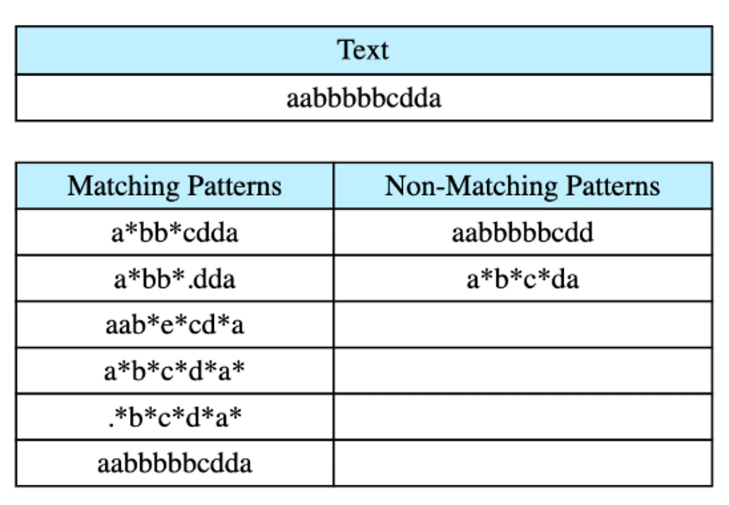

**6)Graphs**

**12. Clone a directed graph**

**Problem Statement**: Given the root node of a directed graph, clone this graph by creating its deep copy so that the cloned graph has the same vertices and edges as the original graph.

**13. Conduct a Breadth-First Traversal of a given graph**

**Problem Statement**: Starting from the source node, traverse a given graph breadthwise to find the distance between the source node and node n.

**14. Check if there’s a path from a source to its destination**

**Problem Statement**: Given a graph n*n with each cell containing a value of 0, 1, 2, or 3, return a true or false value depending on whether or not one can find a path from the source node to the destination node. Each graph will have one source node and one destination node. The graph can be traversed horizontally and vertically.

The cell containing a value of 0 is the source node. A value of 1 represents a wall; this node is impassable. A value of 2 represents a blank cell that can be traversed. A value of 3 represents the destination node.

**7)Sort and Search**

**15. Find the closest meeting point**

**Problem Statement**: Given n people on a square grid, find the point that requires the least total distance covered by all people to meet at that point.

**16. Search for the given key in a two-dimensional matrix**

**Problem Statement**: We are given a two-dimensional array where all elements in any individual row or column are sorted. In such a matrix, we have to search or find the position of a given key.